10.99: In Fig. (10.34(a)), if the vector 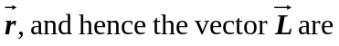with the horizontal, the torque will still be horizontal (the torque must be perpendicular to the vertical weight). The magnitude of the torque will be 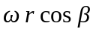, and this torque will change the direction of the horizontal component of the angular momentum, which has magnitude 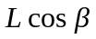. Thus, the situation of Fig. (10.36) is reproduced, but with 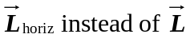. Then, the expression found in Eq. (10.36) becomes

